
Company
Logotype

Cone Beam Computed Tomography- Report



Porur Dental X-rays & CBCT

Patient Name : Mr. Sarathkumar | Date of Report : 09.03.2025
Age/ Gender : 33 years/ Male | Region of Interest : CBCT Sectional Mandible
Referring doctor: Dr. Selvaganesh | Indication : Implant assessment- 46.
Clinical Notes: Nil
PATIENT INFORMATION

CBCT- Sectional Mandible provided
CBCT – IMAGE DETAILS

RADIOGRAPHIC INTERPRETATION

- Presence of hyperdense crown structure in relation to 45, 46, 47.
- The alveolar ridge in relation the mandibular alveolar ridge is present with normal trabecular pattern.

IMPLANT ASSESSMENT

 | 46 region
Sub-Crestal (in mm) | 5.28
Width along the middle third of alveolar ridge  (in mm) | 7.27
Distance between alveolar ridge and the inferior alveolar nerve canal (in mm) | 14.07
Distance between alveolar ridge and the inferior border of mandible (in mm) | 24.93

RADIOGRAPHIC IMPRESSION

- Crown: 45, 46, 47

Kindly correlate with clinical findings


IMAGES FOR REFERENCE

RECONSTRUCTED PANORAMIC VIEW
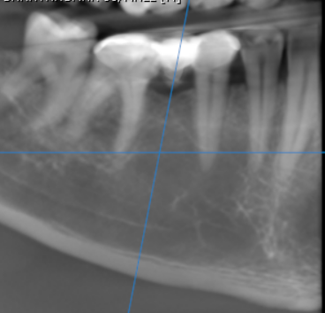

3-DIMENSIONAL VIEW

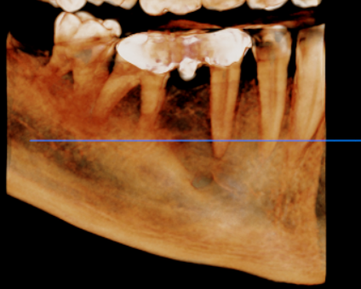

CROSS SECTIONAL VIEW

46 region | 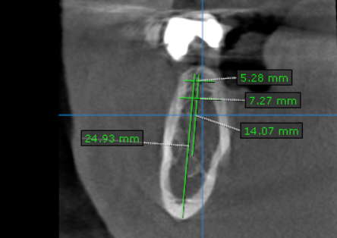

**** End of report ****

